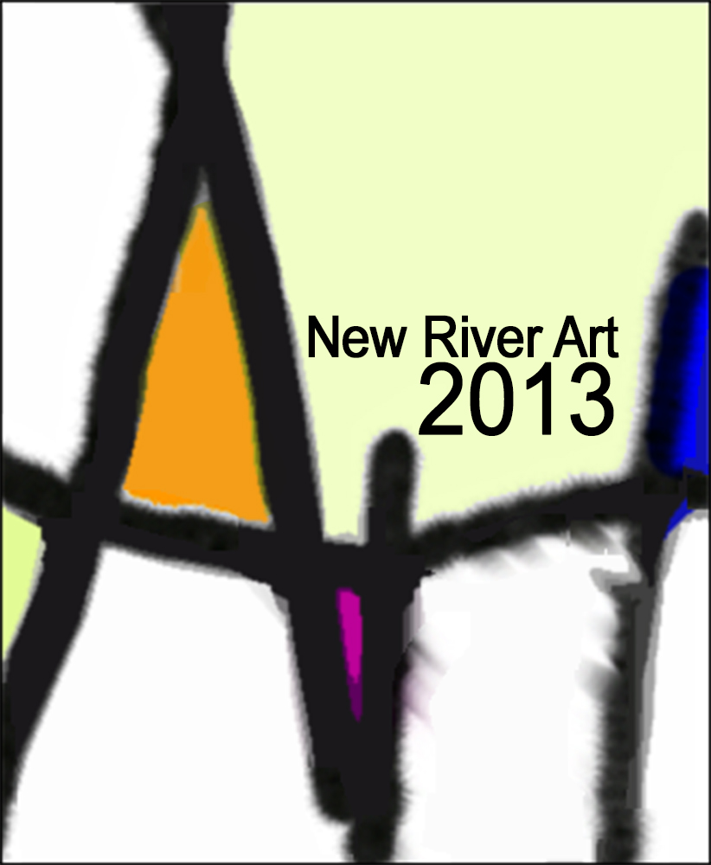
News release – May 9, 2013
www.newriverart.org
Facebook at New River Art

12th New River Art biennial exhibition open for entries
By Gerri Young

The 12th New River Art Juried Biennial Exhibition, organized this year by the Blacksburg Regional Art Association (BRAA), opened for entries the first week of May. It will take its last entry on Aug. 29.
This biennial exhibition, one of the few in the New River Valley area, is being coordinated by the BRAA for the first time since 2007. The committee is made up of members Leslye Bloom, Gerri Young and Diana Francis.
Biennial responsibilities alternate among the BRAA, the Jacksonville Center for the Arts in Floyd, and the Fine Arts Center of the New River Valley in Pulaski. In 2011, Jacksonville led the way. In 2015, the Pulaski art center will be in charge.
Since the BRAA does not have a facility of its own, the committee contracted with Virginia Tech’s Perspective Gallery for the show to run from Oct. 2 to Nov. 7.
“This year,” reports Bloom, “we are making a big change. We decided to seek an online application service to greatly automate the whole process, saving time, handling of paper and CDs and making the jury process entirely online as well.
“We understand the online process might be a bit stressful for some of our artists,” said Bloom, “but the system is quite user friendly and we have developed a help presentation with screen shots and advice for how to do it. Full information about our biennial exhibition can be found by searching for New River Art on
www.callforentry.org. Online help is available as well to any artist who might be having a problem.”
“We expect Call for Entry to speed up and simplify much of the traditional work on managing a show and we hope participating artists will agree,” said Bloom.
By using this online system and marketing it via both traditional means and social media like Facebook and Twitter, the committee hopes to attract both a larger number of artists and younger ones. All 2D and 3D artists 18 and older within 150 miles of Blacksburg are eligible to apply. “This covers a number of colleges and universities with art students so we are really hoping to attract young artists to this show,” stated Bloom.
Another real plus for interested artists is a very nice awards package including nine awards totaling $2,100. Funding for awards came from businesses and individuals in Blacksburg and Roanoke.
On May 1, the coordinators met with a few BRAA members to test the system and conduct training. “The service, called CaFÉ for short, is very well supported,” said Francis. “We went through a couple hours of teleconference to introduce us to the system and train us in its use. The first application was received the very first day the show went live.
“Not only can our members and other interested artists use CaFÉ for the New River show, they can see other calls for exhibition entries registered with the system throughout the U.S.”
Bloom has written a tutorial on preparing digital files at www.newriverart.org, and advises applying artists to print out the information page for the New River show (in CaFÉ) first in order to have the image requirements and file name guidelines at hand during the processing of their photos. “This will definitely save time when it comes to loading those photo files into the My Portfolio section of the site. Once that is done, the actual entering and paying is extremely easy.”
Applying artists may pay online using Visa, MasterCard or PayPal. “We do encourage artists not to pay by check (though it is possible as well),” commented Bloom. “People who are reluctant to use online payments will be able to use checks but they should remember if they wait too long and the check does not make it to the committee by the Aug. 29 deadline, their application could be disqualified.”
Francis reports everything is set to go. Find full information on www.newriverart.org, and on Facebook at New River.

-30-

